Do you care about how our local communities develop?
Are you interested in planning for the future?

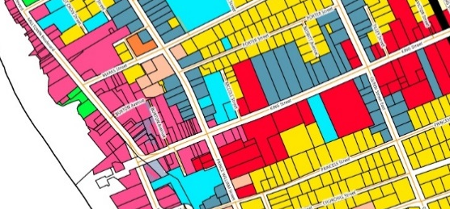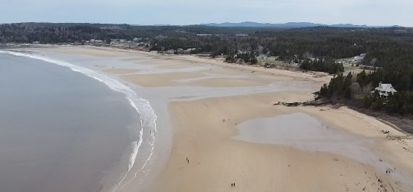

The Southwest New Brunswick Service Commission (SNBSC) is looking for people residing in the region who want to serve on the Planning and Review and Adjustment Committee (PRAC). In joining the committee, you will form part of a diverse team to advise and make recommendations to Councils and the Province on matters relating to local planning. Supported by professional planning staff, you will also make decisions on development applications using by-laws, regulations, and the Community Planning Act.

SNBSC is looking for volunteer committee members who are interested in learning more about planning. In addition, SNBSC is seeking a diversity of skills, perspectives, and geographic representation, for PRAC.

This volunteer role has a basic expected commitment of one (1) meeting each month – third Thursday of each month. Each meeting you will get a per diem and mileage, if travel is required. Many meetings can be held virtually.

To serve as a member of the PRAC, a person must be eligible to vote in Provincial elections. If you are interested, please provide an indication of your interest, as well as a brief description as to why you would be ideal for this role to:

Send your expression of interest to:
SNBSC, 33 Wall Street, St. Stephen, NB E3L 2L5
c/o Alex Henderson, Planning Director
E-mail: alex.henderson@snbsc.ca

Need more information before applying?
Call Alex Henderson at: (506)-466-3141

Deadline for expressions of interest: Tuesday, June 1st, 2021

